ULTIMA 2.0
CS-435 Operating System
Phase 2 – InterProcess Communication

By:

Drake Wood
drawood@iu.edu

James Giegerich
jgiegeri@iu.edu

3/18/19

Table of Contents
Phase Abstract 2
Phase Description 3
Design Diagram 4
Source Code 5
Main.cpp 5
Semaphore.h 8
Semaphore.cpp 10
Window.h 13
Window.cpp 14
Queue.h 24
Queue.cpp 28
Scheduler.h 31
Scheduler.cpp 34
ipc.h……………………………………………………………………………………………………………………………………………….41
ipc.cpp…………………………………………………………………………………………………………………………………………..43
Makefile 52
Output 53

Phase Abstract
This report details the design and development of the second phase of the Ultima 2.0 project for C435. This program is written in C++ and is designed to run on a Unix operating system. This program and design are meant to be added to and upgraded in future iterations to add more features. This report includes the full source code as well as design diagrams.
Before this phase could be started, we had to rework Phase One. The first thing we did was assign the UI loop to its own thread. The second thing was set each thread status to “READY” upon creation. We developed a run() function in the scheduler class to set the first thread to “RUNNING”. Our yield() method was developed to set the current “RUNNING” thread to “READY”, and the find the next “READY” thread and set it to “RUNNING”. Lastly, we reworked our up() and down() methods in the semaphore class to operate as binary semaphores. If the semaphore was already being used, the thread requesting access will get queued until the current thread is finished with the resource for that semaphore.

Phase Description

This phase is to develop and implement a simulated interprocess communication system for the threads in our simulated operating system. One task must be able to send and receive messages from another task. This is done by the use of a physical mailbox queue in the Task Control Block (TCB). The IPC class includes a struct object that includes data members such as the Task ID numbers of the source and destination threads, message arrival time, message size, and the text of the message itself. Included class methods are Message_Send() and Message_Receive() for sending and receiving, Message_Count(int Task_Id) to count the number of messages in a specific task’s mailbox and Message_Count() to tally the number of messages in all collective mailbox queues, Message_Print() to print all queued messages for any given Task ID, Message_DeleteAll() to delete all queued messages in a given task, and ipc_Message_Dump() to print all queued messages for all tasks.
- Each mailbox is given its own semaphore to keep threads from simultaneously writing to the same message queue.
- Message_Send() takes an object of type Message* and enqueues it to the mailbox queue of that message’s destination Task ID.
- Message_Receive() takes in a Task ID and dequeues the first message object on that task’s mailbox queue.
- Message_Print() takes in a Task ID and prints all messages for that task as well as the other Message object data members.
- Message_DeleteAll() takes a Task ID and deletes (dequeues) all messages in that task’s mailbox.
- ipc_Message_Dump() prints all queued messages for all tasks to the Message Dump Window by printing a table header for the data members and then calling Message_Print() once for each Task that has not yet been killed.
The text book Modern Operating Systems by Tanenbaum, C435 class notes, Unix manual, and some online research was used for external information.

Design Diagram
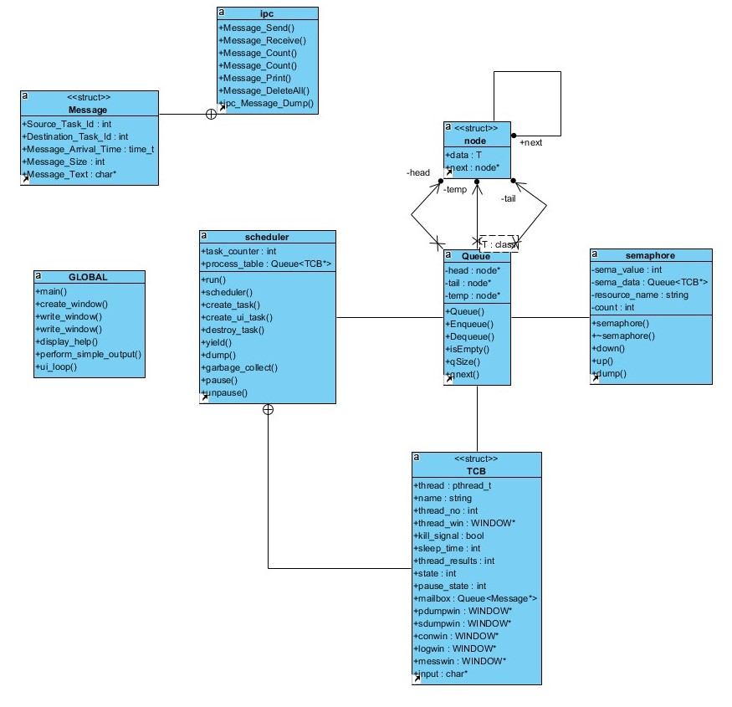

Source Code

Main.cpp

/*==================================================================================|

| Assignment: Ultima 2.0 Phase 2

| File Name: main.cpp

| Dependencies: scheduler.h semaphore.h window.h queue.h

| Authors: Drake Wood, James Giegerich

| Language: C++

| Compiler: G++

| Class: C435 - Operating Systems

| Instructor: Dr. Hakimzadeh

| Date Created: 2/16/2019

| Last Updated: 3/18/2019

| Due Date: 3/18/2019

|==================================================================================|

| Description: Contains the main function that interacts with the scheduler, semaphore, queue, and window classes.

| Multiple curses windows and 3 pthreads are created which are then passed to other functions to handle.

| The rest of main contains an input loop for the user to control what happens while the program is running.

| Details of the way functions are used and their parameters as well as

| computation details are given in the class descriptions.

*==================================================================================*/

#include <iostream>

#include <pthread.h> // Needed for using the pthread library

#include <assert.h>

#include <time.h>

#include <unistd.h> // Needed for sleep()

#include <ncurses.h> // Needed for Curses windowing

#include <stdarg.h> // Needed for formatted output to window

#include <termios.h>

#include <fcntl.h>

#include <cstdlib>

#include "queue.h"

#include "scheduler.h"

#include "semaphore.h"

#include "window.h"

using namespace std;

semaphore sema_screen(1, (char *)"Screen Print"); // creates semaphores

semaphore sema_t1mail(1, (char *)"t1mail");

semaphore sema_t2mail(1, (char *)"t2mail");

semaphore sema_t3mail(1, (char *)"t3mail");

semaphore sema_t4mail(1, (char *)"t4mail");

semaphore sema_ptable(1, (char *)"ptable");

scheduler sched; //creates scheduler

ipc IPC; // creates ipc

//------------------------------------------------------------------------------

//------------------------------MAIN--------------------------------------------

//------------------------------------------------------------------------------

int main() {

initscr(); // Start nCurses

refresh(); // Refresh screen

//------------------------------------------------------------------------------

//Creating heading window, printing content

//------------------------------------------------------------------------------

WINDOW * Heading_Win = newwin(12, 80, 3, 2);

box(Heading_Win, 0,0);

mvwprintw(Heading_Win, 2, 28, "ULTIMA 2.0 (Spring 2019)");

mvwprintw(Heading_Win, 4, 2, "Starting ULTIMA 2.0.....");

mvwprintw(Heading_Win, 5, 2, "Starting Thread 1....");

mvwprintw(Heading_Win, 6, 2, "Starting Thread 2....");

mvwprintw(Heading_Win, 7, 2, "Starting Thread 3....");

mvwprintw(Heading_Win, 9, 2, "Press 'q' or Ctrl-C to exit the program...");

wrefresh(Heading_Win);

//------------------------------------------------------------------------------

//Creating log window

//------------------------------------------------------------------------------

WINDOW * Log_Win = create_window(15, 60, 30, 2);

write_window(Log_Win, 1, 18, "...........Log...........\n");

//------------------------------------------------------------------------------

//Creating console window

//------------------------------------------------------------------------------

WINDOW * Console_Win = create_window(15, 20, 30, 62);

write_window(Console_Win, 1, 1, " ....Console....\n");

write_window(Console_Win, 2, 1, "Ultima # ");

write_window(Log_Win, " Main program started\n" );

//------------------------------------------------------------------------------

//Creating 3 windows for tasks

//------------------------------------------------------------------------------

WINDOW * W1 = create_window(15, 25, 15, 2);

WINDOW * W2 = create_window(15, 25, 15, 30);

WINDOW * W3 = create_window(15, 25, 15, 57);

//------------------------------------------------------------------------------

//Creating a process table dump window

//------------------------------------------------------------------------------

WINDOW * Process_Table = create_window(9, 80, 3, 83);

write_window(Process_Table, 1, 5, " PROCESS TABLE DUMP \n -------------------------------------\n");

//------------------------------------------------------------------------------

//Creating tasks with create_task passing each a name and task window

//------------------------------------------------------------------------------

sched.create_task((char*)" Task 1", W1,Process_Table);

sched.create_task((char*)" Task 2", W2,Process_Table);

sched.create_task((char*)" Task 3", W3,Process_Table);

//-------------------------------------------------------------------------------

//Creating a semaphore dump window

//-------------------------------------------------------------------------------

WINDOW * Sema_Dump = create_window(16, 80, 12, 83);

write_window(Sema_Dump, 1, 5, " SEMAPHORE DUMP \n -------------------------------------\n");

//------------------------------------------------------------------------------

//Create a Messaging dump window

//------------------------------------------------------------------------------

WINDOW * Message_Dump = create_window(17, 80, 28, 83);

write_window(Message_Dump, 1, 5, " MESSAGING DUMP \n -------------------------------------\n");

//------------------------------------------------------------------------------

//Setup for user console input

//------------------------------------------------------------------------------

cbreak(); // Set up keyboard I/O processing

noecho(); // disable line buffering

nodelay(Console_Win, true); // disable automatic echo of characters read by getch(), wgetch()

// nodelay causes getch to be a non-blocking call

//------------------------------------------------------------------------------

//Start threads and run till end of program

//------------------------------------------------------------------------------

sched.run(); //start running all the tasks

sched.create_ui_task(Process_Table, Sema_Dump, Console_Win, Log_Win, Message_Dump);

while(sched.process_table.qSize() != 0){ // loop while threads run

sleep(1);

}

endwin();

return 0;

} // end of main

Semaphore.h

/*==================================================================================|

| Assignment: Ultima 2.0 Phase 2

| File Name: semaphore.h

| Dependencies: scheduler.h

| Authors: Drake Wood, James Giegerich

| Language: C++

| Compiler: G++

| Class: C435 - Operating Systems

| Instructor: Dr. Hakimzadeh

| Date Created: 2/16/2019

| Last Updated: 3/18/2019

| Due Date: 3/18/2019

|==================================================================================|

| Description: This is the header file which defines the class semaphore. There are 3 functions along with a

| constructor and deconstructor.

| -dump displays information related to this class in a window for debugging.

| -up creates a mutex and queues it, effectively locking a critical section.

| -down dequeues a mutex, unlocking it.

*==================================================================================*/

#ifndef SEMAPHORE_H

#define SEMAPHORE_H

#include <iostream>

#include <pthread.h> // Needed for using the pthread library

#include <assert.h>

#include <time.h>

#include <unistd.h> // Needed for sleep()

#include <ncurses.h> // Needed for Curses windowing

#include <stdarg.h> // Needed for formatted output to window

#include <termios.h>

#include <fcntl.h>

#include <cstdlib>

#include "queue.h"

#include "scheduler.h"

#include <string>

class semaphore {

int sema_value; // 0 or 1 in the case of a binary semaphore

Queue <scheduler::TCB*>sema_data;

std::string resource_name; // The name of the resource being managed

int count;

public:

semaphore(int sema_value, char* sema_name);

~semaphore();

void down(); // Get the resource or get queued!

void up(); // Release the resource

void dump(int level, WINDOW * win); // Include some

}; // Functions which will allow you to dump the

#endif // Contents of the semaphore in a readable format.

Semaphore.cpp
/*==================================================================================|
| Assignment: Ultima 2.0 Phase 2
| File Name: semaphore.cpp
| Dependencies: semaphore.h window.h
| Authors: Drake Wood, James Giegerich
| Language: C++
| Compiler: G++
| Class: C435 - Operating Systems
| Instructor: Dr. Hakimzadeh
| Date Created: 2/16/2019
| Last Updated: 3/18/2019
| Due Date: 3/18/2019
|==================================================================================|
| Description: Contains the definitions for the functions outlined in semaphore.h
*==================================================================================*/

#include "window.h"
#include "semaphore.h"
#include "scheduler.h"

extern semaphore sema_screen;
extern scheduler sched;
extern scheduler TCB;

void semaphore::down(){ // Lock resource

scheduler::TCB * tcb; // new tcb object

if (sema_value > 0){ // if no 1 else has access
sema_value--; // get access here
} else{ // if someone else has access then we need to queue and block ourselves
tcb = sched.process_table.Dequeue();
tcb->state = 0; // blocked
sched.process_table.Enqueue(tcb); //add back to process table
sema_data.Enqueue(tcb); // stick in sema queue waitlist

for (int i = 0; i < sched.process_table.qSize() -1 ; i++)
{
tcb = sched.process_table.Dequeue();
sched.process_table.Enqueue(tcb); //shuffle queue
}
}

} // end of down

void semaphore::up(){ // Release the resource

if (sema_data.isEmpty()){ // if no one is in line then set value back to 1
sema_value++;
} else {
scheduler::TCB * tcb = sema_data.Dequeue(); // get first in semaphore queue
scheduler::TCB * tcb2; // new tcb for comparison
for (int i = 0; i < sched.process_table.qSize() ; i++)
{
tcb2 = sched.process_table.Dequeue(); //get scheduler task
if (tcb->thread_no == tcb2->thread_no){ // if task id in scheduler matches the one in semaphore
tcb2->state = 1; //ready // change it to ready from blocked
}
sched.process_table.Enqueue(tcb2); //shuffle queue
}
}
} // end of up

void semaphore::dump(int level, WINDOW * win){
// giving semaphore a resource name

char buff[256];

sprintf(buff, " Resource: %s Sema Value: \t%d \n", resource_name.c_str(), sema_value); // Print the resource name of the current semaphore
write_window(win, buff);

std::string name;
if (sema_data.qSize() > 0){
scheduler::TCB * tcb;

for (int i = 0 ; sema_data.qSize(); i++){
tcb = sema_data.Dequeue();
name = tcb->name;
sema_data.Enqueue(tcb);
sprintf(buff, "%s -> ", name.c_str());
write_window(win, buff);
}
} else{
write_window(win, " \tSema Queue empty\n");
}
} // end of dump

semaphore::semaphore(int sema_value, char* sema_name){
count = 0;
this->sema_value = sema_value;
this->resource_name = sema_name;
}

semaphore::~semaphore(){
}

Window.h

/*==================================================================================|
| Assignment: Ultima 2.0 Phase 2
| File Name: window.h
| Dependencies: none
| Authors: Drake Wood, James Giegerich
| Language: C++
| Compiler: G++
| Class: C435 - Operating Systems
| Instructor: Dr. Hakimzadeh
| Date Created: 2/16/2019
| Last Updated: 3/18/2019
| Due Date: 3/18/2019
|==================================================================================|
| Description: This is the header file which defines the class window. There are 5 functions.
| -create_window draws a new window at a specified size and position, it also turns on scrolling.
| -write_window sends text to a specific window either with a position or without.
| -display_help prints a help window with console options for the user.
| -perform_simple_output is the function that the thread will run while alive, it prints an incrementing message.
*==================================================================================*/

#ifndef WINDOW_H
#define WINDOW_H

#include <iostream>
#include <pthread.h> // Needed for using the pthread library
#include <assert.h>
#include <time.h>
#include <unistd.h> // Needed for sleep()
#include <ncurses.h> // Needed for Curses windowing
#include <stdarg.h> // needed for formatted output to window
#include <termios.h>
#include <fcntl.h>
#include <cstdlib>

WINDOW *create_window(int height, int width, int starty, int startx);
void write_window(WINDOW * Win, const char* text);
void write_window(WINDOW * Win, int x, int y, const char* text);
void display_help(WINDOW * Win);
void *perform_simple_output(void *arguments);
void *ui_loop(void *arguments);

#endif

Window.cpp
/*==================================================================================|
| Assignment: Ultima 2.0 Phase 2
| File Name: window.cpp
| Dependencies: semaphore.h window.h
| Authors: Drake Wood, James Giegerich
| Language: C++
| Compiler: G++
| Class: C435 - Operating Systems
| Instructor: Dr. Hakimzadeh
| Date Created: 2/16/2019
| Last Updated: 3/18/2019
| Due Date: 3/18/2019
|==================================================================================|
| Description: Contains the definitions for the functions outlined in window.h
*==================================================================================*/

#include "window.h"
#include "semaphore.h"
#include "ipc.h"
#include "time.h"

extern semaphore sema_screen;
extern semaphore sema_t1mail;
extern semaphore sema_t2mail;
extern semaphore sema_t3mail;
extern semaphore sema_t4mail;
extern semaphore sema_ptable;
extern scheduler sched;
extern ipc IPC;

WINDOW *create_window(int height, int width, int starty, int startx)
{
sema_screen.down();
WINDOW *Win;
Win = newwin(height, width, starty, startx);
scrollok(Win, TRUE); // Allow scrolling of the window
scroll(Win); // scroll the window
box(Win, 0 , 0); // 0, 0 gives default characters for the vertical and horizontal lines
wrefresh(Win); // draw the window
sema_screen.up();

return Win;
} // end of create_window

void write_window(WINDOW * Win, const char* text)
{
sema_screen.down();
wprintw(Win, text);
box(Win, 0 , 0);
wrefresh(Win); // Draw the window
sema_screen.up();
} // end of write_window

void write_window(WINDOW * Win, int y, int x, const char* text)
{
sema_screen.down();
mvwprintw(Win, y, x, text);
box(Win, 0 , 0);
wrefresh(Win); // Draw the window
sema_screen.up();
} // end of write_window

void display_help(WINDOW * Win)
{
sema_screen.down();
wclear(Win);
sema_screen.up(); // Write window already has its own lock
write_window(Win, 1, 1, "1: Kill Task 1");
write_window(Win, 2, 1, "2: Kill Task 2");
write_window(Win, 3, 1, "3: Kill Task 3");
write_window(Win, 4, 1, "c: Clear Screen");
write_window(Win, 5, 1, "d: Pause + Dump");
write_window(Win, 6, 1, "h: Help Screen");
write_window(Win, 7, 1, "q: Quit");
write_window(Win, 8, 1, "g: Garbage Collect");
write_window(Win, 9, 1, "z: Message testing");

} // end of display_help

void *perform_simple_output(void *arguments)
{
scheduler::TCB * tcb = (scheduler::TCB *) arguments; // Extract the thread arguments: (method 1)
int thread_no = tcb->thread_no; // Cast arguments in to thread_data
WINDOW * Win = tcb->thread_win;
WINDOW * pdumpwin = tcb->pdumpwin;
int CPU_Quantum =0;
int yield_quantum = 0;
char buff[256];
time_t messagetime;

while (tcb->state != 3){ // not dead
while(tcb->state == 2) { // running
if(yield_quantum == 0){ // updates process table when thread gets cpu time
sched.dump(1, pdumpwin);
}

if (CPU_Quantum == 0) { // First thing a task does is send messages
for (int i = 1 ; i < 4; i++){
ipc::Message * message = new ipc::Message; // create message
message->Source_Task_Id = thread_no; // source = this task
message->Destination_Task_Id = i; // destination is every task
message->Message_Text = "message text"; // placeholder text
time(&messagetime); // get time
message->Message_Arrival_Time = messagetime; // store time
message->Message_Size = sizeof(message); // get and store size of message
if (IPC.Message_Send(message) == 1){ // send the message
sprintf(buff, " Message sent\n");
write_window(Win, buff);
}
}
}

if(tcb->kill_signal !=1){ //for some reason we cant die before printing or get corruption for now
sprintf(buff, " Task-%d running #%d\n", thread_no, CPU_Quantum++);
write_window(Win, buff);
}
yield_quantum++;
if (tcb->kill_signal == 1){ // set to be killed
write_window(Win, " I'm dying...\n");
tcb->state = 3;
sched.yield();
}
if (yield_quantum == 1001){// if quantum is up
yield_quantum = 0; //reset
write_window(Win, " I'm yielding...\n");
sched.yield();
//sleep(1);
}
}
} // end while

return 0;
}

void *ui_loop(void *arguments)
{
scheduler::TCB * tcb = (scheduler::TCB *) arguments; // Extract the thread arguments: (method 1)
// Cast arguments in to tcb
WINDOW * pdumpwin = tcb->pdumpwin;
WINDOW * sdumpwin = tcb->sdumpwin;
WINDOW * conwin = tcb->conwin;
WINDOW * logwin = tcb->logwin;
WINDOW * messwin = tcb->messwin;
//char* input = tcb->input;
char buff[256];

while (tcb->state != 3){ // not dead
while(tcb->state == 2) { // running
// updates process table when thread gets cpu time
sched.dump(1, pdumpwin);

switch(wgetch(conwin))
{
case '1':
write_window(conwin, "1 \n Ultima # ");
if (sched.destroy_task(1)){
write_window(logwin, " Task 1 killed. \n");
}else{
write_window(logwin, " Task 1 was already dead... \n ");
}
sched.yield();
break;
case '2':
write_window(conwin, "2 \n Ultima # ");
if (sched.destroy_task(2)){
write_window(logwin, " Task 2 killed. \n");
}else{
write_window(logwin, " Task 2 was already dead... \n ");
}
break;
case '3':
write_window(conwin, "3 \n Ultima # ");
if (sched.destroy_task(3)){
write_window(logwin, " Task 3 killed. \n");
}else{
write_window(logwin, " Task 3 was already dead... \n ");
}
break;
case 'c': // CLEAR

sema_screen.down();
refresh(); // Clear the entire screen (in case it is corrupted)
wclear(conwin); // Clear the Console window
sema_screen.up();

write_window(conwin, 1, 1, "Ultima # ");
break;
case 'd':
write_window(conwin, "d \n Ultima # ");
write_window(logwin, " Paused, press any key to continue... \n");
//sched.pause();
sched.dump(1, pdumpwin); // updates process dump windows

sema_screen.down();
refresh(); // Clear the entire screen (in case it is corrupted)
wclear(sdumpwin); // Clear the sema dump window
wclear(messwin); // Clear the message dump window
sema_screen.up();

write_window(sdumpwin, 1, 5, " SEMAPHORE DUMP \n -------------------------------------\n");
sema_screen.dump(1, sdumpwin);
sema_t1mail.dump(1, sdumpwin);
sema_t2mail.dump(1, sdumpwin);
sema_t3mail.dump(1, sdumpwin);
sema_t4mail.dump(1, sdumpwin);
sema_ptable.dump(1, sdumpwin);

write_window(messwin, 1, 5, " MESSAGING DUMP \n -------------------------------------\n");
IPC.ipc_Message_Dump(messwin);
std::cin.get();
write_window(logwin, " Unpaused... \n");
break;
case 'h': // HELP

display_help(conwin);

break;
case 'g':
sched.garbage_collect();
write_window(conwin, "g \n Ultima # ");
write_window(logwin, " Garbage collect\n");
sched.yield();
break;
case 'q': // QUIT
write_window(logwin," Quiting the main program....\n" );
for (int i = 1; i < 4; i++){
if (sched.destroy_task(i)){ // Killed
sprintf(buff, " Task %d to be killed\n", i);
write_window(logwin, buff);
}else{ // Already dead
sprintf(buff, " Task %d already dead\n", i);
write_window(logwin, buff);
} // end else
} // end if
tcb->kill_signal = 1;
sched.yield();
break;
case 'z': // message test case
IPC.Message_Print(1, messwin); // print messages
sprintf(buff, " # of messages in task1 box = %d \n" , IPC.Message_Count(1));
write_window(messwin, buff);
sprintf(buff, " # of messages in all boxes = %d \n" , IPC.Message_Count());
write_window(messwin, buff);
sprintf(buff, " Deleting messages in task 1 box \n");
write_window(messwin, buff);
IPC.Message_DeleteAll(1);
sprintf(buff, " # of messages in task1 box = %d \n" , IPC.Message_Count(1));
write_window(messwin, buff);
sprintf(buff, " # of messages in all boxes = %d \n" , IPC.Message_Count());
write_window(messwin, buff);
break;
case ERR: // If wgetch() return ERR, that means no keys were pressed
if (tcb->kill_signal == 1){ // set to be killed
write_window(logwin, " UI window dying...\n");
tcb->state = 3;
} else {
//write_window(logwin, " NO INPUT, UI yielding...\n");
sched.yield();
}

break;
default:
write_window(conwin, "\n -Invalid Command\n");
write_window(logwin, " -Invalid Command\n");
write_window(conwin, " Ultima # \n");

break;
} // end switch

if (tcb->state == 3){
write_window(logwin," Ultima 2.0 shutting down...\n" );
sched.garbage_collect();
}
} // while running

} // while not dead

return 0;

}

Queue.h
/*==================================================================================|
| Assignment: Ultima 2.0 Phase 1
| File Name: queue.h
| Dependencies: none
| Authors: Drake Wood, James Giegerich
| Language: C++
| Compiler: G++
| Class: C435 - Operating Systems
| Instructor: Dr. Hakimzadeh
| Date Created: 12/16/2019
| Last Updated: 3/18/2019
| Due Date: 3/18/2019
|==================================================================================|
| Description: This is the header file which defines the queue template class used by the semaphore
| and scheduler classes.
*==================================================================================*/

#ifndef QUEUE_H
#define QUEUE_H

#include <iostream>
#include <pthread.h> // Needed for using the pthread library
#include <assert.h>
#include <time.h>
#include <unistd.h> // Needed for sleep()
#include <ncurses.h> // Needed for Curses windowing
#include <stdarg.h> // needed for formatted output to window
#include <termios.h>
#include <fcntl.h>
#include <cstdlib>

template <class T>
class Queue{
private:
struct node{
T data;
node* next;
};
node* head;
node* tail;
node* temp;

public:
Queue();
void Enqueue(const T data);
T Dequeue();
bool isEmpty();
int qSize();
T qnext();
};

// Constructor.
template <class T>
Queue<T>::Queue(){
head = NULL;
tail = NULL;
temp = NULL;
}

template <class T>
int Queue<T>::qSize(){
int count = 0;
temp = head;

if (isEmpty()){
return count;
} // end if
else if (temp->next == NULL){
count++;
return count;
} // end if
else{
while (temp != NULL){
count++;
temp = temp->next;
} // end while

return count;
} // end else
} // end of qSize

//get data of next item, will probably be able to use this in yield
//so that we can pass the cpu to the next ID in the QUIT
//also in semaphore dump to show the Q there
template <class T>
T Queue<T>::qnext(){
T returnData;
returnData = head->next->data;
return returnData;
}

// Enqueues new node and populates the data
// with T data as passed in.
template <class T>
void Queue<T>::Enqueue(const T data){
if (tail == NULL){
head = tail = new node;
tail->next = NULL;
tail->data = data;
} // end if
else {
tail->next = new node;
tail->next->data = data;
tail->next->next = NULL;
tail = tail->next;
} // end else
} // end of Enqueue

// Dequeues node and returns data stored
// in dequeued node.
template <class T>
T Queue<T>::Dequeue(){
T returnData;
returnData = head->data;
temp = head->next;
delete head;
head = temp;
tail = (!head? NULL: tail);
return returnData;
}

// Checks if the queue is empty.
template <class T>
bool Queue<T>::isEmpty(){
return (!tail);
}

#endif

Queue.cpp
/*==================================================================================|
| Assignment: Ultima 2.0 Phase 1
| File Name: queue.cpp
| Dependencies: queue.h
| Authors: Drake Wood, James Giegerich
| Language: C++
| Compiler: G++
| Class: C435 - Operating Systems
| Instructor: Dr. Hakimzadeh
| Date Created: 2/16/2019
| Last Updated: 3/18/2019
| Due Date: 3/19/2019
|==================================================================================|
| Description: Contains the definitions for the functions outlined in queue.h
*==================================================================================*/

#include "queue.h"

// Constructor
template <class T>
Queue<T>::Queue(){
head = NULL;
tail = NULL;
temp = NULL;
}

template <class T>
int Queue<T>::qSize(){
int count = 0;
temp = head;

if (isEmpty()){
return count;
} // end if
else if (temp->next == NULL){
count++;
return count;
} // end if
else{
while (temp != NULL){
count++;
temp = temp->next;
} // end while
return count;
} // end else
} // end of qSize

// Enqueues new node and populates the data
// with T data as passed in.
template <class T>
void Queue<T>::Enqueue(const T data){
if (tail == NULL){
head = tail = new node;
tail->next = NULL;
tail->data = data;
} // end if
else {
tail->next = new node;
tail->next->data = data;
tail->next->next = NULL;
tail = tail->next;
} // end else
} // end Enqueue

// Dequeues node and returns data stored
// in dequeued node.
template <class T>
T Queue<T>::Dequeue(){
T returnData;
returnData = head->data;
temp = head->next;
delete head;
head = temp;
tail = (!head? NULL: tail);
return returnData;
}

// Checks if the queue is empty.
template <class T>
bool Queue<T>::isEmpty(){
return (!tail);
}
struct thread_data{
int thread_no;
char* thread_name;
WINDOW *thread_win;
bool kill_signal;
int sleep_time;
int thread_results;
bool state;
};

Scheduler.h
/*==================================================================================|
| Assignment: Ultima 2.0 Phase 2
| File Name: scheduler.h
| Dependencies: queue.h
| Authors: Drake Wood, James Giegerich
| Language: C++
| Compiler: G++
| Class: C435 - Operating Systems
| Instructor: Dr. Hakimzadeh
| Date Created: 2/16/2019
| Last Updated: 3/18/2019
| Due Date: 3/18/2019
|==================================================================================|
| Description: This is the header file which defines the class scheduler. There are 4 functions along with a
| constructor, deconstructor, and data structs.
| -dump displays information related to this class in a window for debugging.
| -garbage_collect finds threads that have been killed adn removes them from the process table.
| -create_task creates a new thread running simple output, its information is added to the process table.
| -destroy_task finds the task that the user wishes to kill and changes it status, stopping it.
| -TCB is the struct containing the thread_data which is stored in the process queue.
*==================================================================================*/

#ifndef SCHEDULER_H
#define SCHEDULER_H

#include <iostream>
#include <pthread.h> // Needed for using the pthread library
#include <assert.h>
#include <time.h>
#include <unistd.h> // Needed for sleep()
#include <ncurses.h> // Needed for Curses windowing
#include <stdarg.h> // Needed for formatted output to window
#include <termios.h>
#include <fcntl.h>
#include <cstdlib>
#include "queue.h"
#include <string>
#include "ipc.h"

class scheduler {
public:
struct TCB {
pthread_t thread;
std::string name;
int thread_no; // Thread number
WINDOW *thread_win; // Thread's window
bool kill_signal; // Kill signal flag live/kill
int sleep_time; // Sleep time
int thread_results; // Results
int state;
int pause_state;
Queue<ipc::Message*> mailbox;
WINDOW *pdumpwin; // these are for the main input
WINDOW *sdumpwin;
WINDOW *conwin;
WINDOW *logwin;
WINDOW *messwin;
char *input;
};

void run();
scheduler();
int task_counter;
Queue <TCB*>process_table;
int create_task(char* name, WINDOW *win, WINDOW *pdumpwin); // Create appropriate data structures and calls coroutine()
int create_ui_task(WINDOW *pdumpwin, WINDOW *sdumpwin, WINDOW *conwin, WINDOW *logwin, WINDOW * messwin);
bool destroy_task(int tasknumber); // to kill a task (Set its status to DEAD)
void yield(); // Strict round robin process switch.
void dump(int level, WINDOW * win); // Debugging function with level indicating the verbosity of the dump
void garbage_collect(); // Include some functions which will allow you to dump the contents of the
void pause();
void unpause();
}; // process table in a readable format. See the expected output section
#endif // (below) for suggestions.
// remove dead task, free their resources, etc.

Scheduler.cpp

/*==================================================================================|
| Assignment: Ultima 2.0 Phase 2
| File Name: scheduler.cpp
| Dependencies: scheduler.h semaphore.h window.h
| Authors: Drake Wood, James Giegerich
| Language: C++
| Compiler: G++
| Class: C435 - Operating Systems
| Instructor: Dr. Hakimzadeh
| Date Created: 2/16/2019
| Last Updated: 3/18/2019
| Due Date: 3/18/2019
|==================================================================================|
| Description: Contains the definitions for the functions outlined in scheduler.h
*==================================================================================*/

#include "semaphore.h"
#include "scheduler.h"
#include "window.h"

#define BLOCKED 0
#define READY 1
#define RUNNING 2
#define DEAD 3

extern semaphore sema_screen;
extern semaphore sema_ptable;

void scheduler::dump(int level, WINDOW * win) {
sema_screen.down();
wclear(win);
sema_screen.up();
write_window(win, 1, 5, " PROCESS TABLE DUMP \n -------------------------------------\n");
char buff[256];
int procnum1;
int size = process_table.qSize();

if (size == 0) // Check if anything is in the queue
write_window(win, " No tasks currently running...\n");
sema_ptable.down();
for(int i = 0 ; i < size ; i++){ // Search for a dead task
TCB *tcb = process_table.Dequeue();
process_table.Enqueue(tcb);
procnum1 = tcb->thread_no;

if ( tcb->state == READY){
sprintf(buff, " Task #%d status Ready\n", procnum1);
}
else if (tcb->state == RUNNING){
sprintf(buff, " Task #%d status Running\n", procnum1);
}
else if (tcb->state == BLOCKED){
sprintf(buff, " Task #%d status Blocked\n", procnum1);
}
else if (tcb->state == DEAD){
sprintf(buff, " Task #%d status Dead\n", procnum1);
}// end else
write_window(win, buff);
} // end for
sema_ptable.up();
write_window(win, " -------------------------------------\n");
}// end of dump

void scheduler::garbage_collect() { // Delete those with dead status
sema_ptable.down();
int size = process_table.qSize();
for(int i = 0 ; i < size ; i++){
TCB *tcb = process_table.Dequeue();
if (tcb->state != DEAD){
process_table.Enqueue(tcb);
} // end if
} // end for
sema_ptable.up();
} // end of garbage_collect

int scheduler::create_task(char* name, WINDOW *win, WINDOW *pdumpwin){
int result_code;
TCB * tcb = new TCB;
this->task_counter++;
tcb->thread_win = win;
tcb->pdumpwin = pdumpwin;
write_window(tcb->thread_win, 13, 1, "Starting Thread.....\n");
tcb->thread_no = this->task_counter;
tcb->name = name;
tcb->state = READY;

// create thread running simple output in its own window
result_code = pthread_create(&tcb->thread, NULL, perform_simple_output, tcb);
assert(!result_code); // if there is any problems with result code. display it and end program.
sema_ptable.down();
process_table.Enqueue(tcb); // add to process table
sema_ptable.up();
return 0;
} // end of create_task

int scheduler::create_ui_task(WINDOW *pdumpwin, WINDOW *sdumpwin, WINDOW *conwin, WINDOW *logwin, WINDOW * messwin){
int result_code;
TCB * tcb = new TCB;
this->task_counter++;
tcb->pdumpwin = pdumpwin;
tcb->sdumpwin = sdumpwin;
tcb->conwin = conwin;
tcb->logwin = logwin;
tcb->messwin = messwin;

tcb->thread_no = this->task_counter;
tcb->name = (char*) "UI Thread";
tcb->state = READY;

// create thread ui loop
result_code = pthread_create(&tcb->thread, NULL, ui_loop, tcb);
assert(!result_code); // if there is any problems with result code. display it and end program.
sema_ptable.down();
process_table.Enqueue(tcb); // add to process table
sema_ptable.up();
return 0;
}
scheduler::scheduler(){
task_counter = 0;
}

bool scheduler::destroy_task(int tasknumber) {
bool flag = false;
sema_ptable.down();
for( int i =0; i < process_table.qSize(); i++){
if (!process_table.isEmpty()){ // this block searches Q for a specific process
TCB *tcb = process_table.Dequeue();
process_table.Enqueue(tcb); // if it is found kill signal is changed

if (tcb->thread_no == tasknumber){
if (tcb->kill_signal == 0){ // other processes are added back to Q
tcb->kill_signal = 1;
flag = true;
}else { //already killed.
//return 0;
} // end else
} // end if
} // end if
} // end for
sema_ptable.up();
return flag;
} // end of destroy_task

void scheduler::yield() { // Give scheduler the option to change state to ready or to continue running
sema_ptable.down();
// Change current thread state to READY.
TCB * tcb = process_table.Dequeue();
if (tcb->state != DEAD){ //dont ready if yielding after death
tcb->state = READY;
}
process_table.Enqueue(tcb);

// Find a thread that is READY.
tcb = process_table.Dequeue();
while (tcb->state != READY){ // might get stuck here?
process_table.Enqueue(tcb);
tcb = process_table.Dequeue();
}

tcb->state = RUNNING;
process_table.Enqueue(tcb);

// Shuffle the queue to put runnning thread back at front of queue.
for (int i = 0; i < (process_table.qSize() - 1); i++){
tcb = process_table.Dequeue();
process_table.Enqueue(tcb);
}
sema_ptable.up();
}

void scheduler::run(){
sema_ptable.down();
TCB *tcb = process_table.Dequeue();
tcb->state = RUNNING;
process_table.Enqueue(tcb);

// Shuffle the queue to put runnning thread back at front of queue.
for (int i = 0; i < (process_table.qSize() - 1); i++){
tcb = process_table.Dequeue();
process_table.Enqueue(tcb);
}
sema_ptable.up();
}

void scheduler::pause(){
sema_ptable.down();
for (int i = 0; i < (process_table.qSize()); i++){
TCB * tcb = process_table.Dequeue();
tcb->pause_state = tcb->state;
tcb->state = BLOCKED;
process_table.Enqueue(tcb);
}
sema_ptable.up();
}

void scheduler::unpause(){
sema_ptable.down();
for (int i = 0; i < (process_table.qSize()); i++){
TCB * tcb = process_table.Dequeue();
if (tcb->state != DEAD){
tcb->state = tcb->pause_state;
}

process_table.Enqueue(tcb);
}
sema_ptable.up();
}

ipc.h

/*==================================================================================|
| Assignment: Ultima 2.0 Phase 2
| File Name: ipc.h
| Dependencies: none
| Authors: Drake Wood, James Giegerich
| Language: C++
| Compiler: G++
| Class: C435 - Operating Systems
| Instructor: Dr. Hakimzadeh
| Date Created: 3/3/2019
| Last Updated: 3/18/2019
| Due Date: 3/18/2019
|==================================================================================|
| Description: This is the header file which defines the class ipc.
| This class contains 7 funtions and a message structure.
| -Message_Send takes a message as parameter and delivers it to destination.
| -Message_Receive reads first message in mailbox for given task.
| -Message_Count (single) returns the number of messages for given task.
| -Message_Count (all) returns total number of messages in all mailboxes.
| -Message_Print prints all messages for given task.
| -Message_DeleteAll delets all messages for given task.
| -ipc_Message_Dump prints all messages for all mailboxes.
*==================================================================================*/

#ifndef IPC_H
#define IPC_H

class ipc {
public:
struct Message {
int Source_Task_Id;
int Destination_Task_Id;
time_t Message_Arrival_Time; // research time.h, time_t, and tm
int Message_Size;
char *Message_Text;
//etc.
} ;
int Message_Send(Message *message); // returns -1 if error occurred. Return 1 if successful.
int Message_Receive(int Task_id, Message *message); // returns 0 if no more messages are available, loads the Message structure with
// the first message from the mailbox and remove the message from the mailbox.
// Return -1 if an error occurs.
int Message_Count(int Task_id); // return the number of messages in Task-id’s message queue.
int Message_Count(); // return the total number of messages in all the message queues.
void Message_Print(int Task_id, WINDOW * Win); // print the all messages for a given Task-id.
int Message_DeleteAll(int Task_id); // delete all the messages for Task_id
void ipc_Message_Dump(WINDOW * Win); // print all the messages in the message queue, but do not delete them from the queue.
// (note that this function may be best placed in the scheduler!)
};
#endif

ipc.cpp
/*==================================================================================|
| Assignment: Ultima 2.0 Phase 2
| File Name: ipc.cpp
| Dependencies: ipc.h window.h queue.h scheduler.h semaphore.h
| Authors: Drake Wood, James Giegerich
| Language: C++
| Compiler: G++
| Class: C435 - Operating Systems
| Instructor: Dr. Hakimzadeh
| Date Created: 3/3/2019
| Last Updated: 3/18/2019
| Due Date: 3/18/2019
|==================================================================================|
| Description: Contains the definitions for the functions outlined in ipc.h
*==================================================================================*/

#include "window.h"
#include "queue.h"
#include "scheduler.h"
#include "ipc.h"
#include "semaphore.h"

extern semaphore sema_screen;
extern semaphore sema_t1mail;
extern semaphore sema_t2mail;
extern semaphore sema_t3mail;
extern semaphore sema_t4mail;
extern semaphore sema_ptable;
extern scheduler sched;
extern scheduler TCB;

// Sends message using destination in the message which is passed
int ipc::Message_Send( Message *message){
// returns -1 if error occurred. Return 1 if successful.
sema_ptable.down();
int flag = -1;
int dtID = message->Destination_Task_Id; // gets destination task
scheduler::TCB * tcb;

switch(dtID) // switch for using correct semaphore
{
case '1':
sema_t1mail.down();
break;
case '2':
sema_t2mail.down();
break;
case '3':
sema_t3mail.down();
break;
case '4':
sema_t4mail.down();
break;
}

for (int i = 0; i < sched.process_table.qSize(); i++){ // searches process table for the destination task
tcb = sched.process_table.Dequeue();
if (dtID == tcb->thread_no){

tcb->mailbox.Enqueue(message); // enqueues the message in the tasks mailbox
flag = 1;
}
sched.process_table.Enqueue(tcb); //add back to process table.
}
switch(dtID) // switch for using correct semaphore
{
case '1':
sema_t1mail.up();
break;
case '2':
sema_t2mail.up();
break;
case '3':
sema_t3mail.up();
break;
case '4':
sema_t4mail.up();
break;
}
sema_ptable.up();
return flag;
}

int ipc::Message_Receive(int Task_id, Message *message){
// returns 0 if no more messages are available, loads the Message structure with
sema_ptable.down(); // the first message from the mailbox and remove the message from the mailbox.
// Return -1 if an error occurs.
int flag = -1;
int dtID = message->Destination_Task_Id;
scheduler::TCB * tcb;

switch(dtID)// switch for using correct semaphore
{
case '1':
sema_t1mail.down();
break;
case '2':
sema_t2mail.down();
break;
case '3':
sema_t3mail.down();
break;
case '4':
sema_t4mail.down();
break;
}

for (int i = 0; i < sched.process_table.qSize(); i++){
tcb = sched.process_table.Dequeue();
if (dtID == tcb->thread_no){ // finds task
if (!tcb->mailbox.isEmpty()){ // gets first message from its mailbox
message = tcb->mailbox.Dequeue();
flag = 1; // message found
}
else{
flag = 0; // message not found
}
}
sched.process_table.Enqueue(tcb); //add back to process table.
}

switch(dtID)// switch for using correct semaphore
{
case '1':
sema_t1mail.up();
break;
case '2':
sema_t2mail.up();
break;
case '3':
sema_t3mail.up();
break;
case '4':
sema_t4mail.up();
break;
}
sema_ptable.up();
return flag;
}

int ipc::Message_Count(int Task_id){ // return the number of messages in Task-id’s message queue.
sema_ptable.down();
int count = 0;
scheduler::TCB * tcb;

for (int i = 0; i < sched.process_table.qSize(); i++){
tcb = sched.process_table.Dequeue(); // find task
if (Task_id == tcb->thread_no){
count = tcb->mailbox.qSize(); // gets number of messages
}
sched.process_table.Enqueue(tcb); //add back to process table.
}

sema_ptable.up();
return count;
}

int ipc::Message_Count(){ // return the total number of messages in all the message queues.
sema_ptable.down();
int count = 0;
scheduler::TCB * tcb;

for (int i = 0; i < sched.process_table.qSize(); i++){ // cycle all tasks
tcb = sched.process_table.Dequeue();
count += tcb->mailbox.qSize(); // add up number of messages
sched.process_table.Enqueue(tcb); //add back to process table.
}
sema_ptable.up();
return count;
}

void ipc::Message_Print(int Task_id, WINDOW * Win){ // print the all messages for a given Task-id.
sema_ptable.down();
scheduler::TCB * tcb;
char buff[256];
Message * mess;
struct tm * timeinfo; // create the time data struct for extracting the format from the Message_Arrival_Time

for (int i = 0; i < sched.process_table.qSize(); i++){
tcb = sched.process_table.Dequeue();
if (Task_id == tcb->thread_no){

switch(Task_id)// switch for using correct semaphore
{
case '1':
sema_t1mail.down();
break;
case '2':
sema_t2mail.down();
break;
case '3':
sema_t3mail.down();
break;
case '4':
sema_t4mail.down();
break;
}

sprintf(buff, " Time\t\tSize\tContent\t\tDestination\tSource\n"); // collumn names for message printing
write_window(Win, buff);
for (int j = 0; j < tcb->mailbox.qSize(); j++){
mess = tcb->mailbox.Dequeue();
timeinfo = localtime (&mess->Message_Arrival_Time); // change time to local time
// and store in the new struct
// formatting can be found in time.h for day month year ect.
sprintf(buff, " %d:%d:%d\t%d\t%s\t%d\t\t%d \n", timeinfo->tm_hour,timeinfo->tm_min,timeinfo->tm_sec,
mess->Message_Size, mess->Message_Text, mess->Destination_Task_Id, mess->Source_Task_Id);
write_window(Win, buff); // single line output of all message data
tcb->mailbox.Enqueue(mess);
}
}
sched.process_table.Enqueue(tcb); //add back to process table.

switch(Task_id)// switch for using correct semaphore
{
case '1':
sema_t1mail.up();
break;
case '2':
sema_t2mail.up();
break;
case '3':
sema_t3mail.up();
break;
case '4':
sema_t4mail.up();
break;
}
}
sema_ptable.up();
}

int ipc::Message_DeleteAll(int Task_id){ // delete all the messages for Task_id
sema_ptable.down();
scheduler::TCB * tcb;

for (int i = 0; i < sched.process_table.qSize(); i++){
tcb = sched.process_table.Dequeue();
if (Task_id == tcb->thread_no){

switch(Task_id)// switch for using correct semaphore
{
case '1':
sema_t1mail.down();
break;
case '2':
sema_t2mail.down();
break;
case '3':
sema_t3mail.down();
break;
case '4':
sema_t4mail.down();
break;
}

while (!tcb->mailbox.isEmpty()){
tcb->mailbox.Dequeue();
}

switch(Task_id)// switch for using correct semaphore
{
case '1':
sema_t1mail.up();
break;
case '2':
sema_t2mail.up();
break;
case '3':
sema_t3mail.up();
break;
case '4':
sema_t4mail.up();
break;
}

}
sched.process_table.Enqueue(tcb); //add back to process table.
}
sema_ptable.up();
return 1;
}

void ipc::ipc_Message_Dump(WINDOW * Win){
// print all the messages in the message queue, but do not delete them from the queue.

for (int i = 1; i < 5; i++){
Message_Print(i, Win);
}
}

Makefile

# Make file for Ultima 2.0
# Drake Wood, James Giegerich

# Variables to control Makefile operation

CXX = g++
LINKS = -lpthread -lncurses
CXXFLAGS = -Wall -g

# Targets needed to bring the executable up to date

main: main.o scheduler.o semaphore.o window.o ipc.o
$(CXX) $(CXXFLAGS) -o main main.o scheduler.o semaphore.o window.o ipc.o $(LINKS)

main.o: main.cpp scheduler.h semaphore.h queue.h window.h
$(CXX) $(CXXFLAGS) -c main.cpp $(LINKS)

window.o: window.h window.cpp semaphore.h ipc.h
$(CXX) $(CXXFLAGS) -c window.cpp $(LINKS)

scheduler.o: scheduler.h scheduler.cpp queue.h window.h
$(CXX) $(CXXFLAGS) -c scheduler.cpp $(LINKS)

semaphore.o: semaphore.h semaphore.cpp queue.h window.h
$(CXX) $(CXXFLAGS) -c semaphore.cpp $(LINKS)

ipc.o: ipc.h ipc.cpp scheduler.h queue.h window.h
$(CXX) $(CXXFLAGS) -c ipc.cpp $(LINKS)
clean:
rm *.o

Output

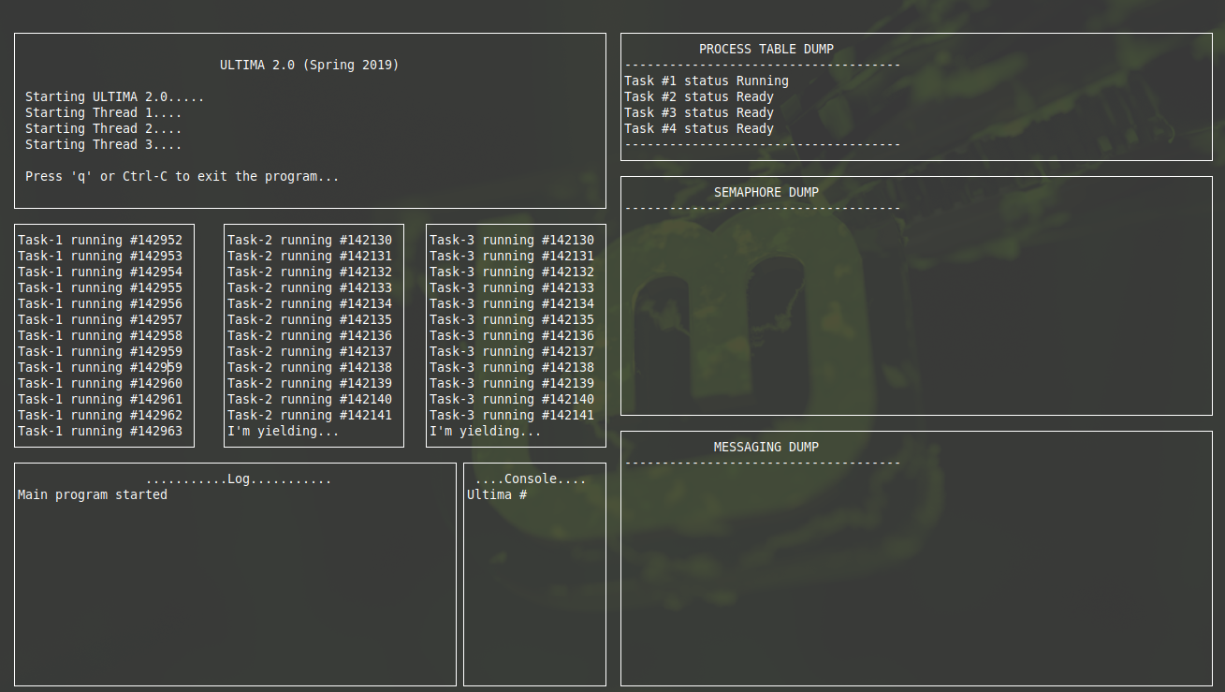
Main screen showing processes yielding to each other in order with the process table keeping track of which is currently running. The semaphore and message dump windows are left blank until dump is called in the next screenshot.
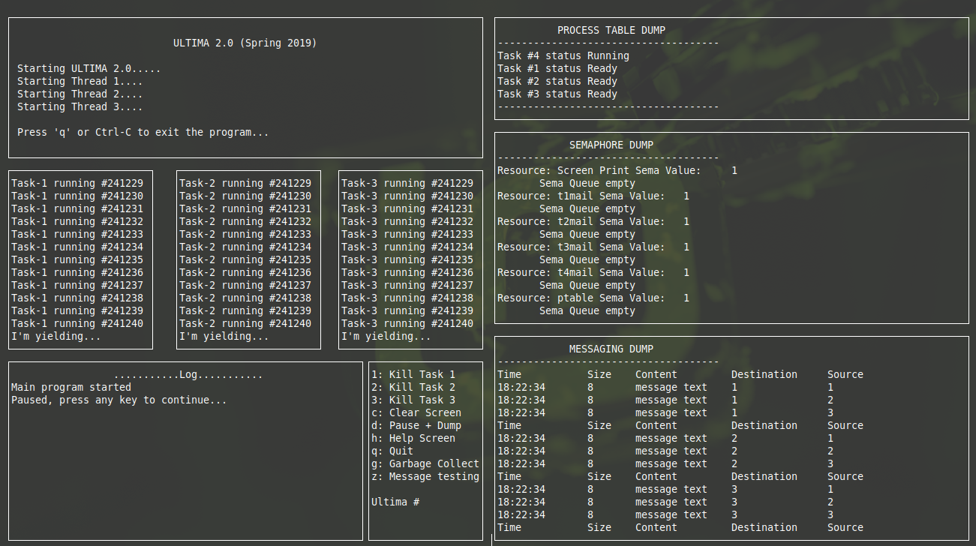
Here is the dump function, each process sends a message to the others and itself and they are displayed.
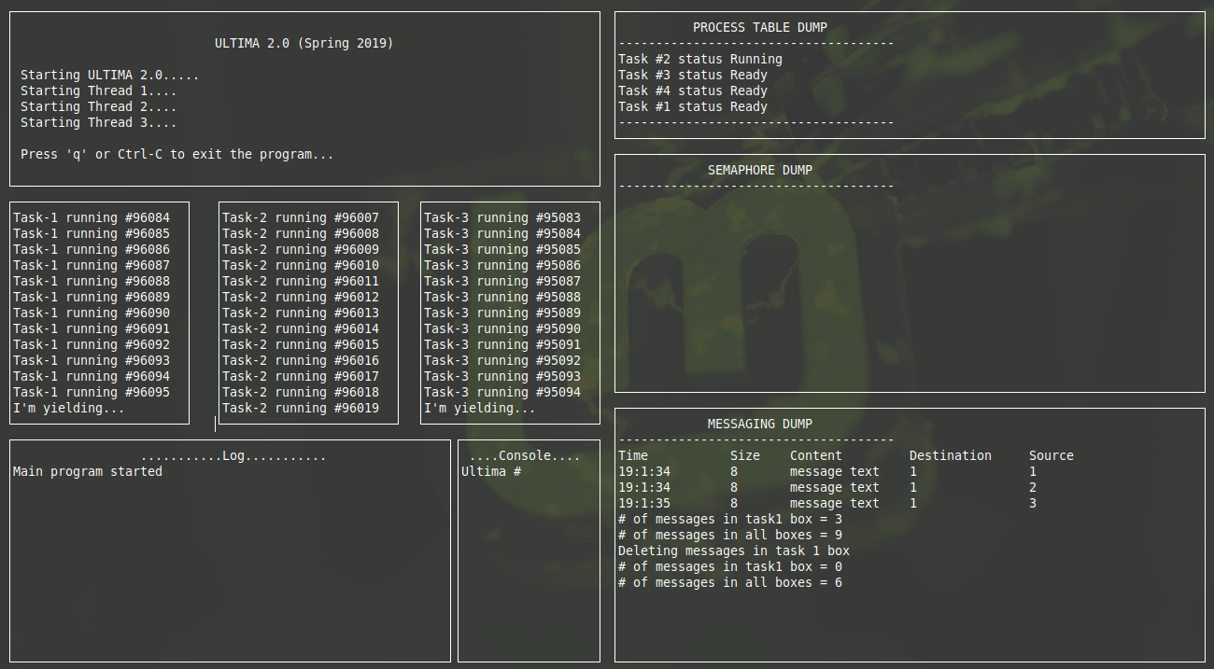
An option z was added for input which ran a series of functions for testing messaging. First the entire mailbox for task 1 was displayed, like before it has 3 messages. The functions for single task count and all task count are called followed by the deletion of all task 1’s messages. You can see when the message count functions are called afterwards that they all perform correctly.

